Twitchy Kitty Corpsing & Making Movable Joints

1. **First step – Adding movement with actuator and spring (see Adrian’s write up/video)- this could be done later in the process as well, either after making movable joints and dry brushing or after initial corpsing. Either works!**
2. **Second step – making movable joints and adjusting leg/head position.**
   1. The way the cat skeleton comes, you cannot move most of the joints at all and cannot easily achieve the look of a curled up dead cat as done by Oak Lane Cemetery. The cat has straight legs, and this looks quite different from the classic “undead kitty” (figure 1). If you are OK with this, feel free to skip this step as it does add time; just remember it will be difficult to change your mind after you have done all the corpsing and finishing.

Fig. 1- Top: Unaltered cat skeleton; Middle: [“Undead Kitty” from Oak Lane Cemetery](https://youtu.be/nrzDGHWk_gs) after finishing; Bottom: My version of cat skeleton dry brushed with movable joints (back spine has not yet been cut).

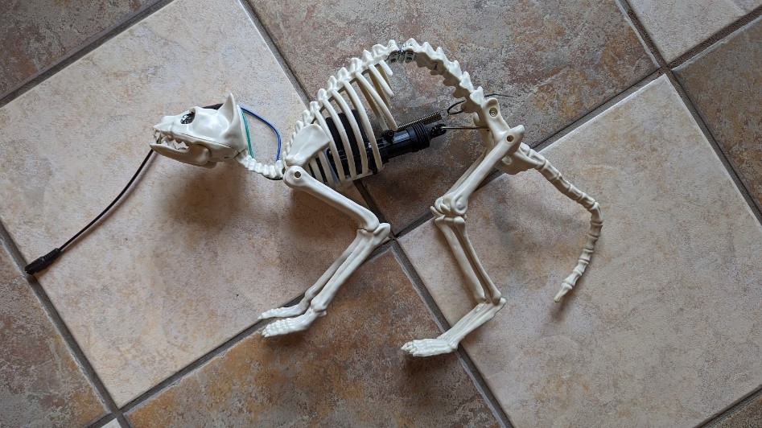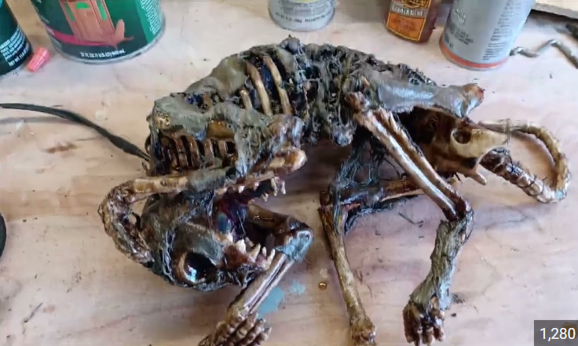

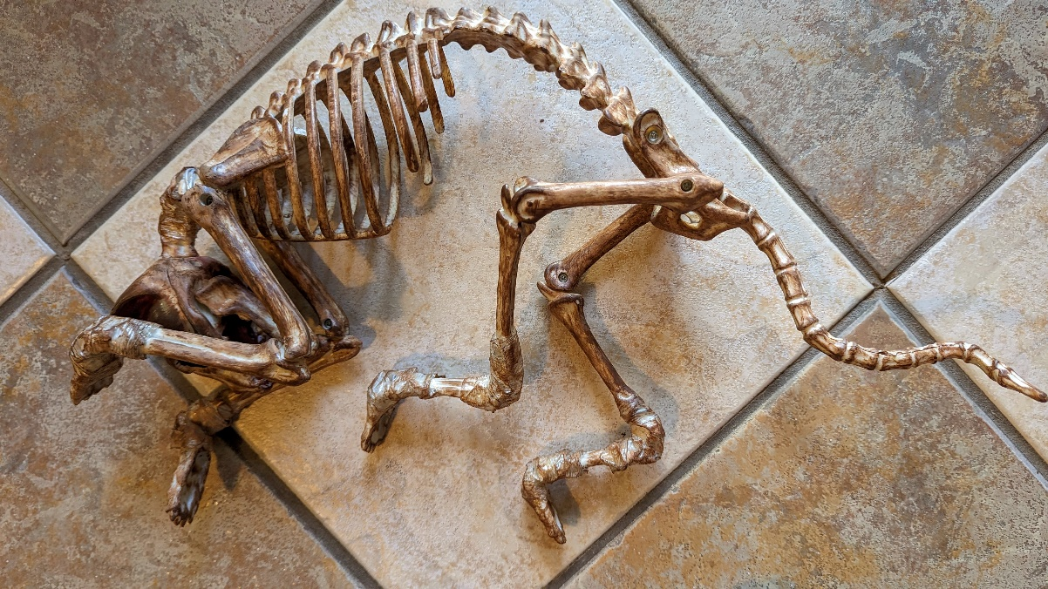

**As you can see – making movable joints is cooler than leaving the cat skeleton the way it comes originally.**

* 1. **Initial steps:** Some of the joints (hips, shoulders, front “elbows” and back knees have screws in them and can be unscrewed, but this still doesn’t allow repositioning. Jeff or Adrian can help you carve off some plastic to allow some additional movement and then screw the joints back into the skeleton to reposition the cat limbs, so it is closer to the Oak Lane “dead cat” (fig 2 below). However, in order to get your cat completely poised to look like the undead kitty prop, you will also need to make the solid joints flexible.
  2. **Making solid joints flexible:** For the solid joints on the legs (all four feet and the back “ankles”) and the neck, you will need to cut through the plastic of the joint. The easiest way we’ve found to do this is with a Dremel saw attachment, although a hacksaw will work.

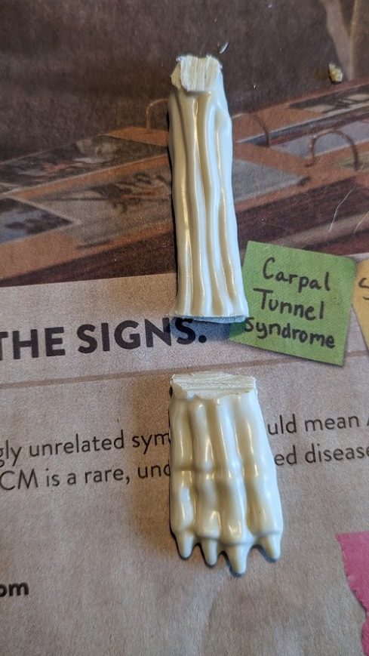

Once the joints are cut, use flexible wire (0.1 cm flexible armature wire or thin flexible steel wire for floral arrangements works) to wrap around each side of the joint, with one or two strands crossing the joint. Leave some space between the two sides to make sure you can bend the joint to the position you want in the end – test this by bending the joint to the desired position. (See below)

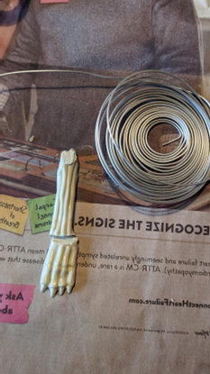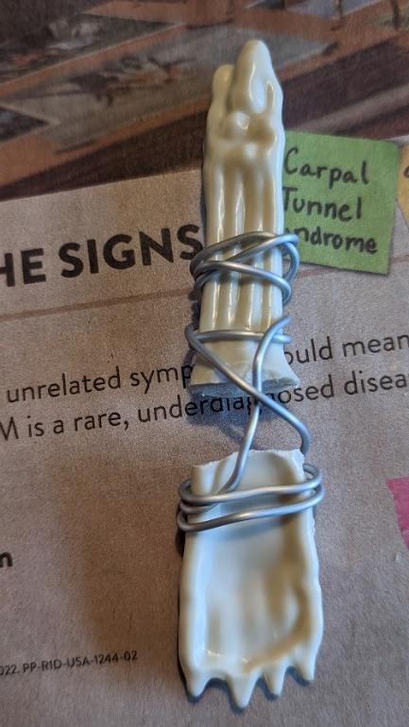

After this, using the strapping tape, tape over the wire to hold in place. As you do this, continue to bend the joint to the desired position to make sure it will bend this far and loosen the tape as needed. The tape will keep the wire from slipping and will disguise it.

The other leg joints can be done similarly to the above.

* 1. **Head and neck joint:** The cat comes with a nonflexible neck that arches up, and a head that can rotate horizontally. In order to make it bend down and match the undead kitty prop, you need to cut the neck near the shoulders (leaving enough spine to attach wires to) and then you turn the entire separated head and neck upside down so the neck arches down.

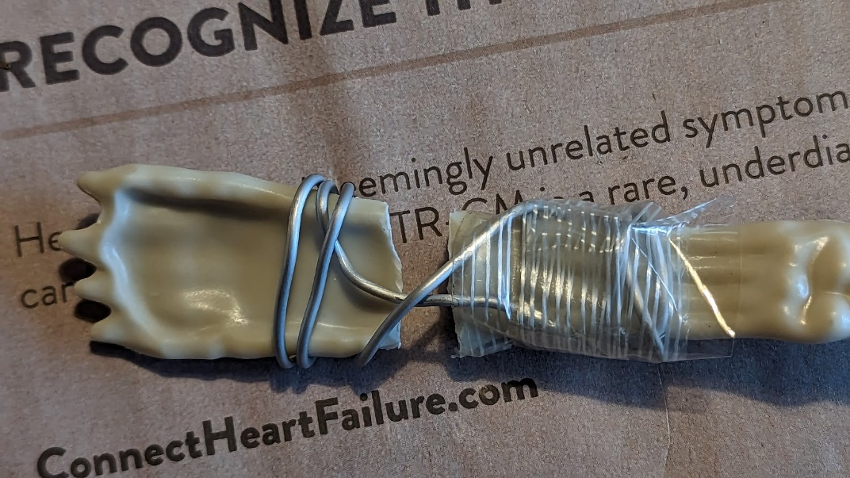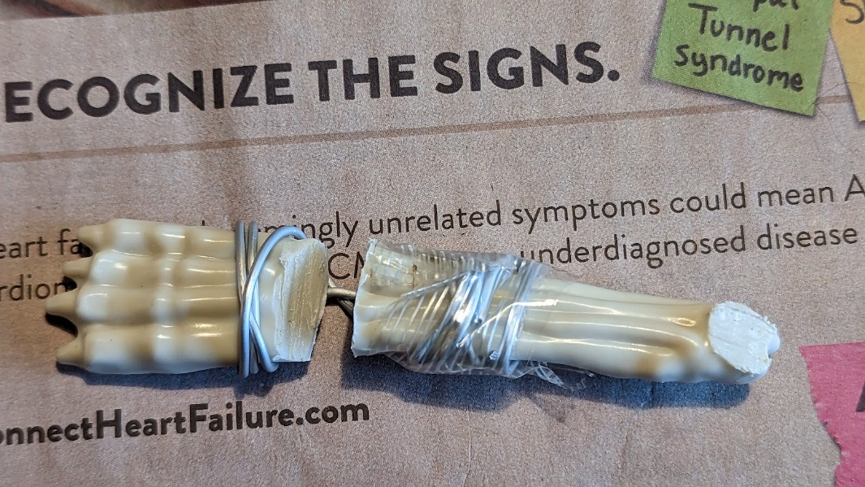

1. **Third step – aging skeleton with dry brushing and creating muscles:** Both of these are optional, but if you are letting the bones show through your corpsing (as with the original twitchy kitty), it looks better to age the skeleton first. Cheap white plastic doesn’t look that good.

The muscles are definitely optional, but can fill out your cat if you want a more “fresh” zombie cat and it also looks cool to show muscles through the outer corpsed skin. (See the bottom picture)

* 1. **Dry brushing** is something many people already know how to do, but if you are unfamiliar, **here’s the basics**.
     1. Start with a medium brown and use a very small amount of paint on your brush. Either squeeze this out with a paper towel until it is almost dry or sweep it back and forth on newspaper until it is almost dry. Go over your skeleton with a very light touch, not using too much paint, but hitting all areas. This should pick up details and “age” the skeleton.
     2. Let this dry; then do the same thing with a lighter cream or very light brown (you can mix cream with a touch of brown or just choose another color that is a very light brown/beige/cream). This “highlights” the skeleton.
     3. I usually also then use a darker color brown after this dries to pick up more detail.
     4. Go back and forth with each color to get the effect you desire.
     5. When you have a good looking “old” skeleton, let dry completely (this doesn’t take long). An example of a dry brushed cat skeleton is the top picture below this section.
  2. If you want to make muscles (to see how they look, see the middle picture below this section), it is really easy. Just fold plastic into a rectangular pad of plastic and tape into place (see the picture below or notes in the plastic corpsing instructions to see where to tape them). Then shrink onto the bones a little bit with the heat gun. If you are going to let them show through holes in the “skin”, I would paint them with a dark red (red mixed with brown to the color of old steak) before corpsing.
  3. The final picture shows the cat corpsed before painting with some muscles showing through the plastic “skin”.

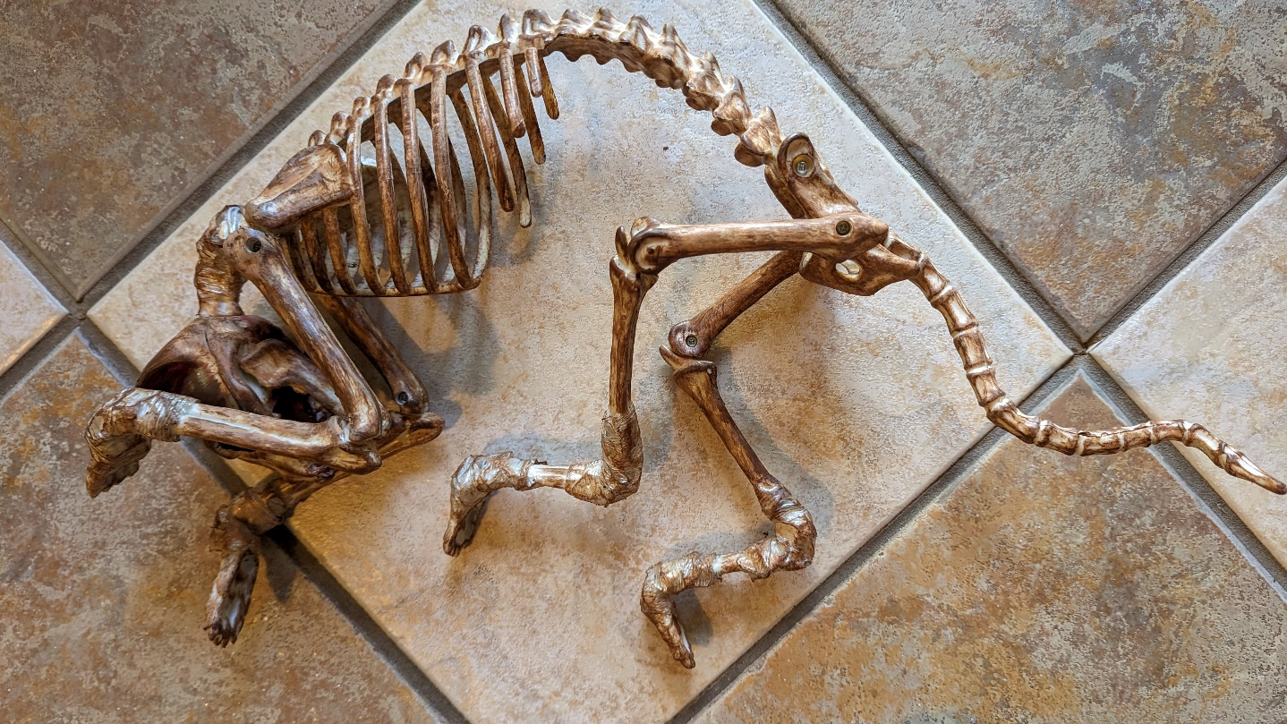

1. **Fourth step – Basic Plastic Corpsing: From My Ghoul Friday, with additions from Suzanne Coberly, especially on the cat skeleton:** <http://www.ghoulfriday.com/how_to/corpsing_skeleton_part_1>
   1. **See attached corpsing instructions.** Since the cat in the instructions was a standing cat skeleton, see the picture in the previous section to see what twitchy cat looks like before painting (above).
   2. **Notes about corpsing for twitchy cat:** Since twitchy cat is going to move, you need to be aware that your corpsing will restrict movement. Go ahead and corpse your cat after putting the actuator in, but before painting, you will need to test the movement. If the plastic restricts the movement too much, you can cut (or melt) some plastic away from the restricted area.
   3. **Finishing the cat:** After that, you just paint and dry brush the cat (follow instructions in the basic corpsing) and if too much of the actuator is showing, you can use creepy cloth with latex to hide the actuator (this cloth is flexible and moves with the cat). Hair or eyes can also be added at this time.

Latex covered cloth will take more time to dry, up to a few days if very humid; more typically 1-2 days.

Here’s the corpsed cat with paint, eyes, and drybrushing:

